Graphics Programming; Labs 1,2,3 G00326349- Ryan Gordon

I had a question in regards to a result I gotten from Lab 3 ball. When the ball bounces it gains momentum from each bounce however when it hits the top wall (ceiling) the ball sticks and moves along the wall for a moment before falling.

I assumed this was the effect of gravity constant force pushing upward could keep the ball there but I wanted to ask was this what was happening or was it a mistake on my part.

Lab 1

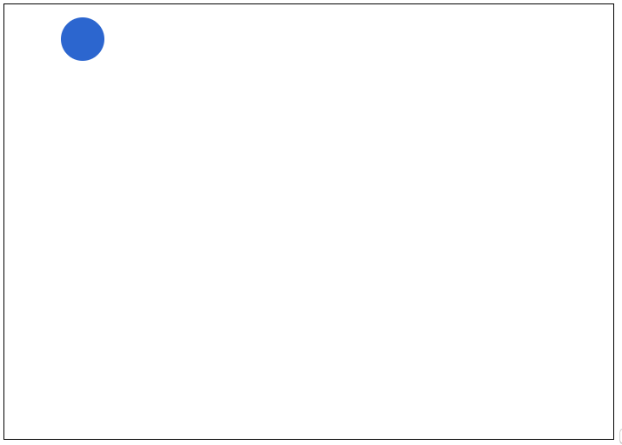

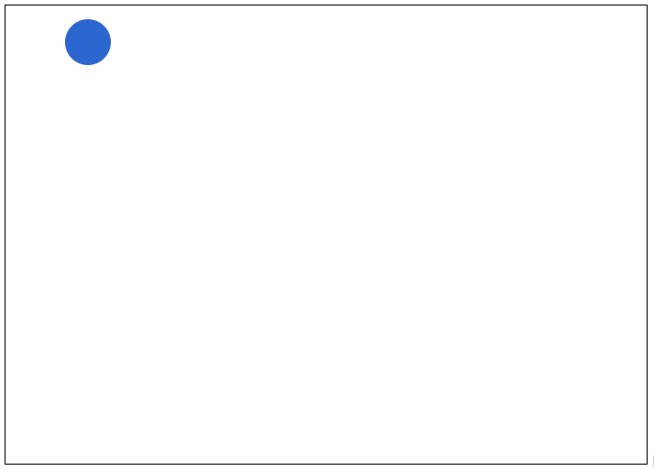

Ball resize

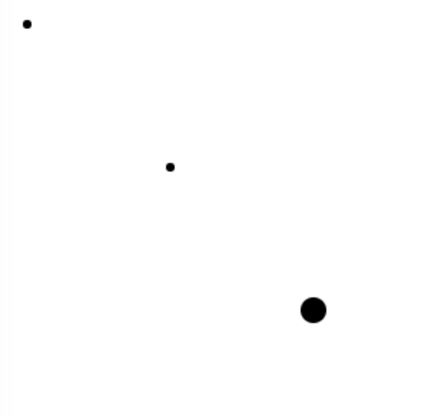

Pacman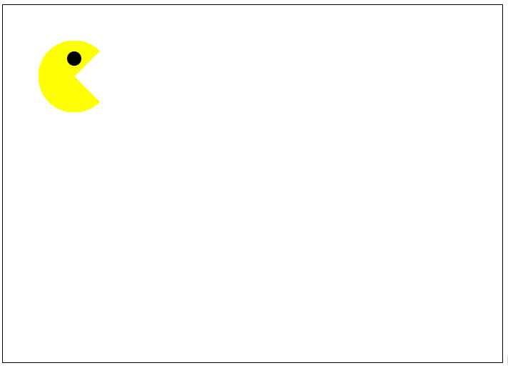

Lab 2

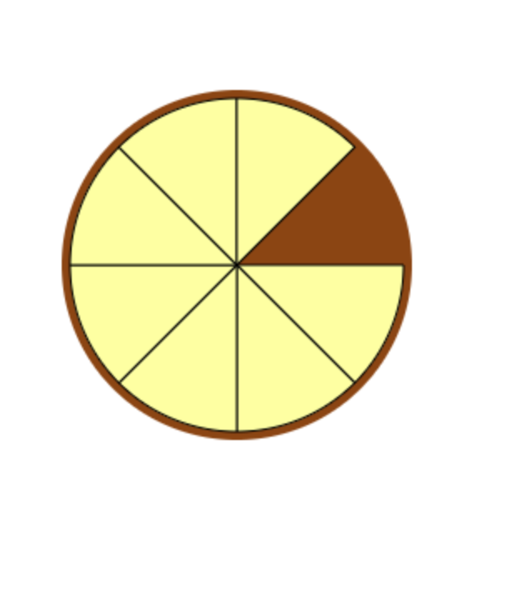

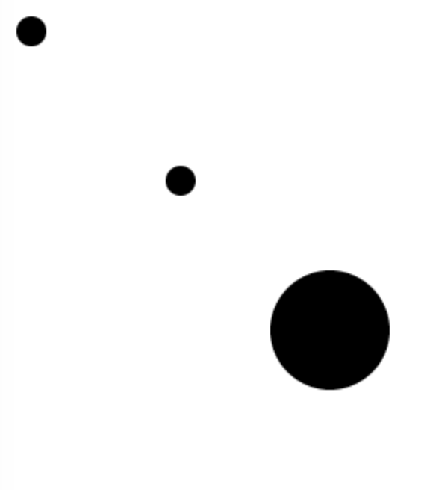

Lab 3

